Cairo University Faculty of Computers and Information



**CS352 – Software Engineering II**

**Daily scrum meeting template**

**2018**

AL Italya lebadat al bugs

|  |  |  |  |
| --- | --- | --- | --- |
| **ID** | **Name** | **Email** | **Mobile** |
| 20150332 | Ahmed Amr Ali Al-Akwah |  |  |
| 20150365 | Mohamed Fadl Al-Hdrmi |  |  |
| 20150321 | Noura AbdulKarim Mohammed |  |  |
| 20150331 | Hosam Eldeen Reda Abdulhady |  |  |
|  |  |  |  |
|  |  |  |  |

Contents

Instructions [To be removed] 2

Done requirements 2

What will be done today 2

Current obstacles 3

Current Trello workspace 3

# Done requirements

**Ahmed: Created GitHub master branch, Implemented Admin Class, Implemented User Class, Fixed database user addition errors.**

**Mohamed: Sprint 1 requirement analysis, Design form login, Design Add product page, Validate inputs from user.**

**Noura: Create Trello account, Create Sequence Diagram, Design Register form, Design show all products page, Validate inputs from user.**

**Hosam: Explain Agile process, Create Class Diagram, Implement Class Product, Implement Class Product Controller,** **Fix Errors in Addition Product on database.**

# What will be done today

**Ahmed: check the files is received correct on GitHub, Implement Classes but he had errors, Fix Errors in Addition User on database and test it.**

**Mohamed: Explain the requirements of sprint 1 to team members, Take the team's view into the design, Validate inputs from user and test it.**

**Noura: send request to the team members, Implement Sequence Diagram, Take the team's view into the design, Validate inputs from user and test it.**

**Hosam: Explain the concepts of agile to team members, Implement Classes but he had errors, Fix Errors in Addition User on database and test it.**

# Current obstacles

**Ahmed: the connection of internet is bad I failed to search, errors in inheritance (User, Admin).**

**Mohamed: I have problem on running Project.**

**Noura: Intelliji IDE GitHub integration problems.**

**Hosam: Errors on add product on database.**

# Current Trello workspace

* **Provide screen shot for your trello workspace**
* **Your screenshot should show product backlog (current requirements) and role of each members**

**Example:**

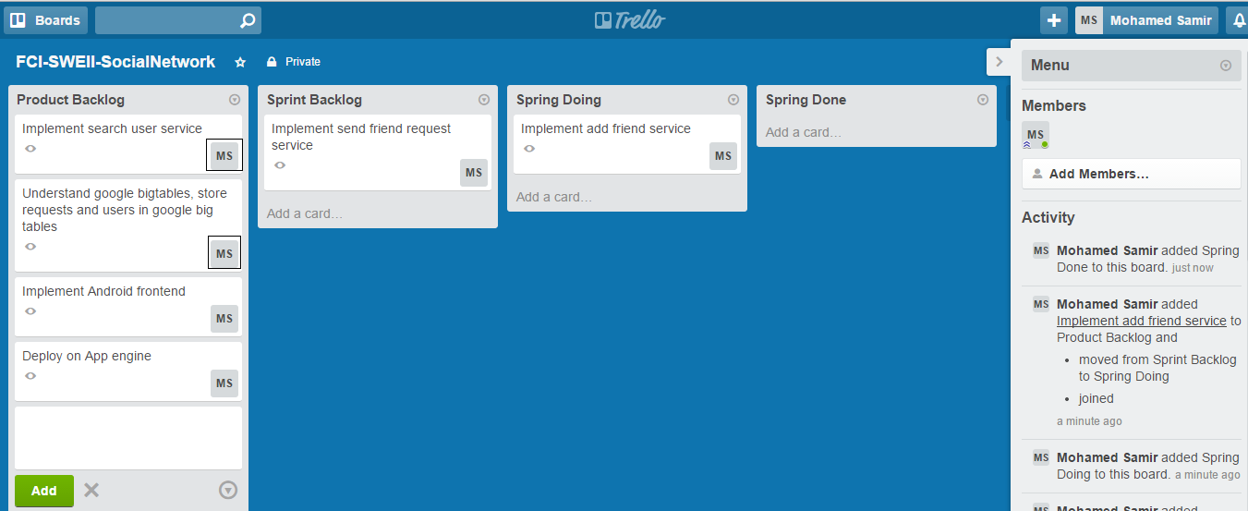

**Note black boxes which state who is responsible for each requirement**